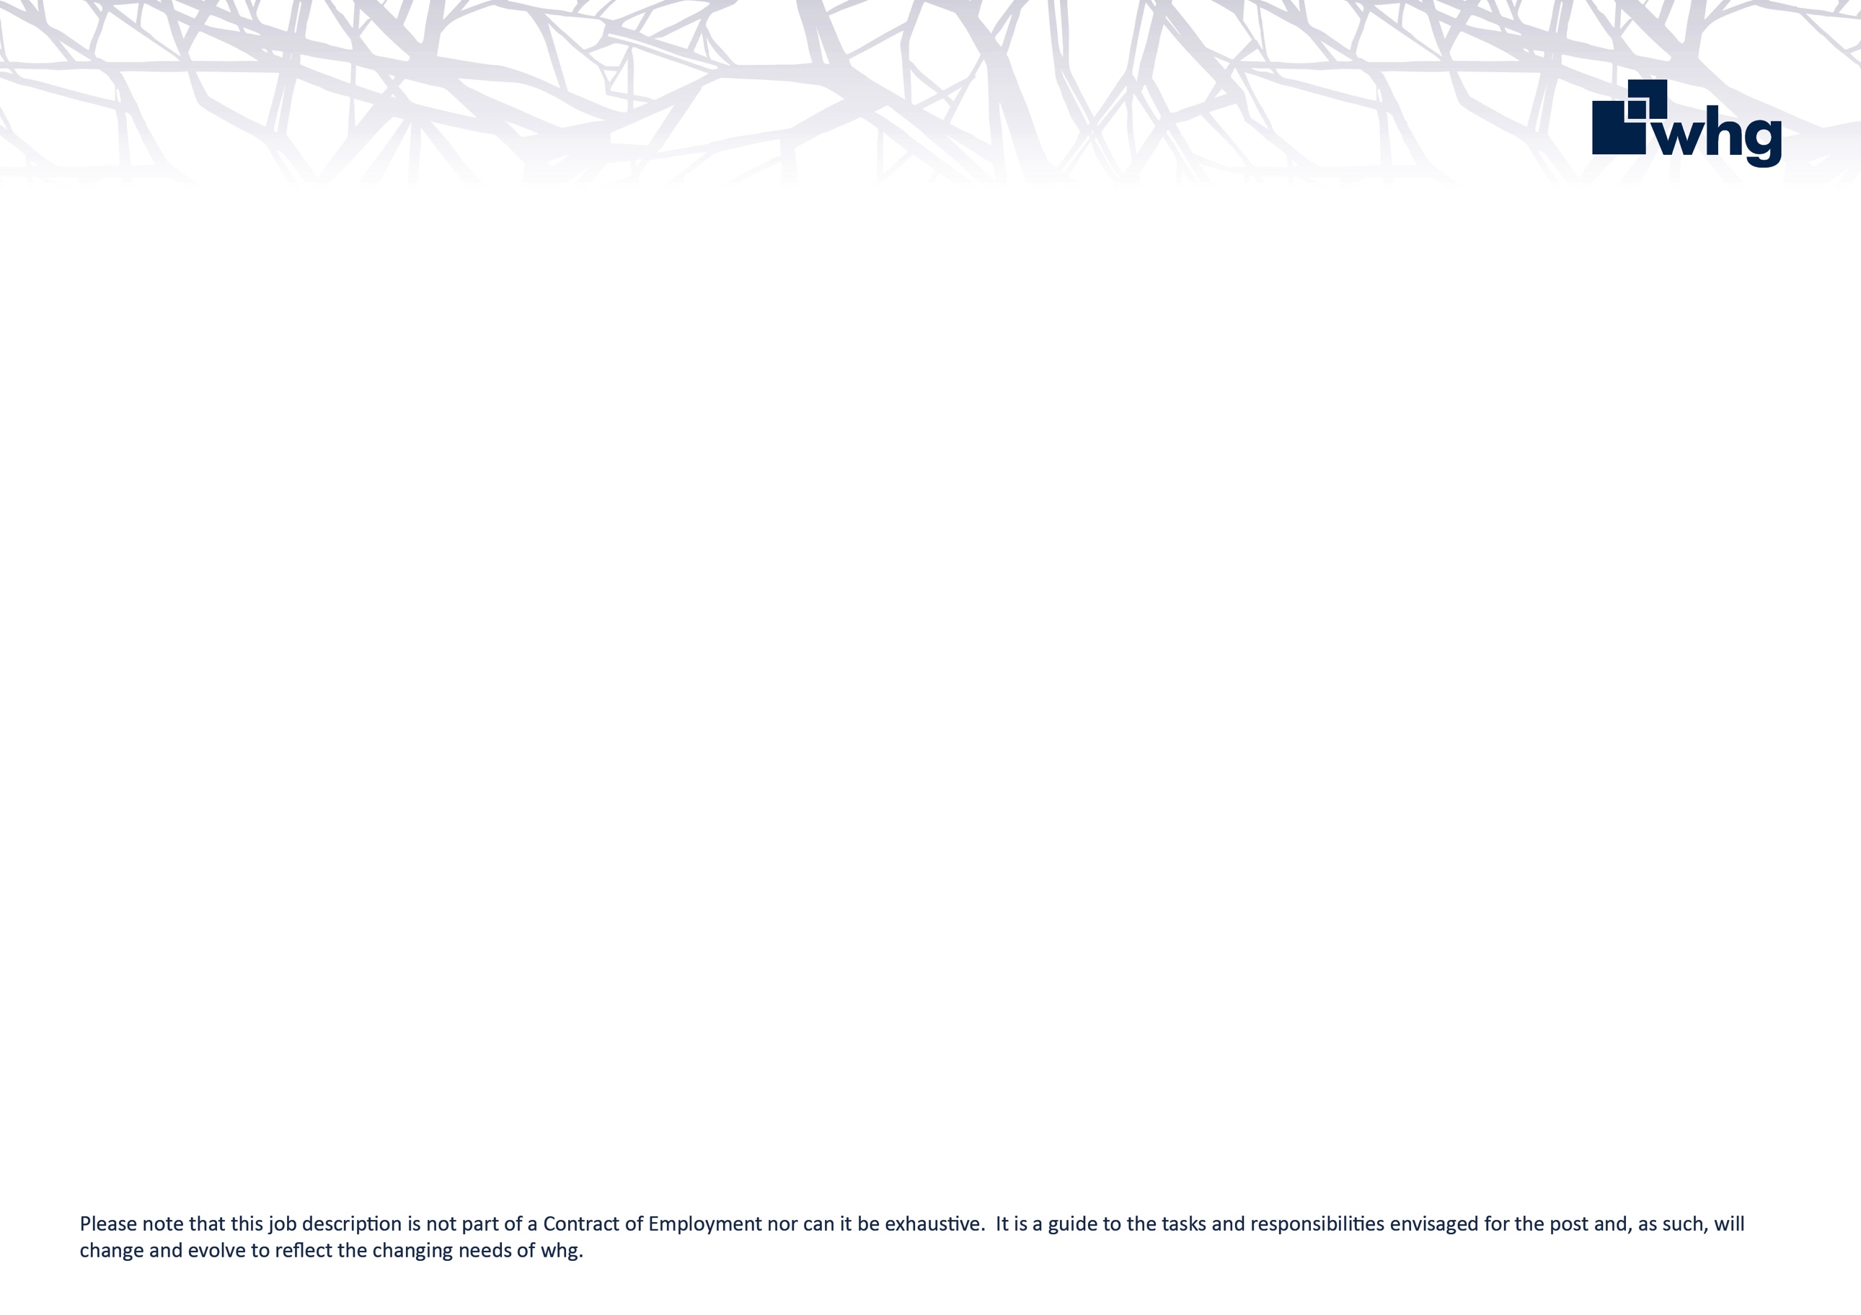
Your role is to provide comprehensive administrative support to the Asset Management Team.
Administrator (Home Maintenance Services)

What are my key responsibilities?

To provide a response to customer enquiries in an effective and timely manner.

To maintain and update IT systems, including MIS with information relating to whg’s customers, repairs, and complaints with their resolution.

To maintain the asset data register and internal recording registers.

To provide administrative support in placing orders/raising jobs for appointments, progress chasing orders and advising customers accordingly.

To provide assistance in preparing detailed reports though various systems.

To conduct customer surveys and compile results.

To provide information and support to Customer Repair Planners through direction from the Lead Planner and Planning Team Leaders.

To carry out regular telephone quality assurance checks on operative’s jobs and report back on your findings.

To promote the Health and Safety, Environmental, Quality, Standards and Compliance agendas within the Home Maintenance Team.

Deliver against Key Performance Indicators and individual targets.

To carry out any other duties commensurate with the grade of the post as may be considered appropriate by the Lead Planner and Planning Team Leaders.

Relationships

There is no supervisory/management responsibility attached to this post.

You’ll report directly to the Planning Team Leader.

You’ll work closely with Customer Repair Planners, other Administrators, Customer Services and Trades Colleagues, as well as Repairs Team Leaders and Home Maintenance Services Managers.

You’ll also liaise directly with customers and subcontractors.

Role Requirements:

- A qualification at Level 2 in English and Maths
- Experience and knowledge of using IT based information to compile and produce reports, ideally with knowledge of housing management systems.
- The ability to effectively use Microsoft packages such as Word, Excel and Outlook.
- Excellent customer service skills.
- Experience of providing support to a number of people within a team environment.
- Excellent administration and organisational skills.
- An ability to communicate effectively both verbally and in writing, within the organisation and with external contacts, and whg customers.
- The ability to anticipate and identify problems and determine the appropriate action to resolve them.
- The ability to build co-operative working relationships with colleagues and partners, treating them with professional and personal respect.
- A flexible and adaptable approach to work and able to work to deadlines.
- The ability to work under pressure in a fast-paced environment.

You will have a confident and positive approach with the ability to remain calm under pressure and deal with difficult situations in an effective, professional and respectful manner. You will also be self-motivated and accountable with the ability to work across teams.

whg’s values and behaviours

At whg we have an ambitious aim to be an exceptional place to work that attracts, develops and retains talent.
We recognise that our success as a business depends largely on the quality and commitment of our colleagues; our values set out in the Corporate Plan identify the behaviours that we expect all colleagues to display at whg.

 | Trustworthy  You can rely on us. We are honest in everything we do.
 | Accountable  Taking responsibility for our actions and owning the delivery of our promises.
 | Excellent  Striving to be the best and delivering the best outcomes for customers and the organisation.
 | Respectful  Valuing people and treating everyone with empathy and fairness.
 | Collaborative  Achieving great things by working together.

