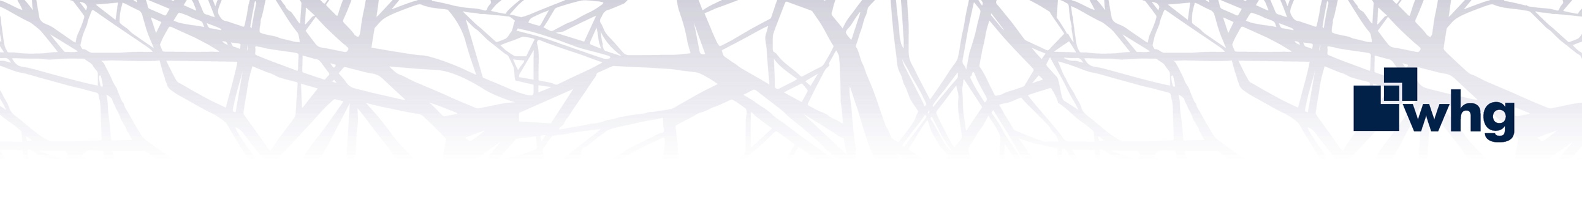
You will play a pivotal role in ensuring successful adoption and embedding of change across all project and organisational activity. You will focus on supporting stakeholder readiness, adoption, and benefits realisation, helping teams successfully transition to and sustain new ways of working.

What are my key responsibilities?

Support adoption and embedding of organisational, service and strategic change initiatives. Promoting awareness, understanding, and successful uptake of change and benefits.

Support the monitoring and measurement of change adoption following implementation.

Support the tracking and realisation of benefits, ensuring expected outcomes are embedded and sustained following project delivery.

Identify and address barriers to change adoption, working closely with project teams to mitigate risks and resolve issues.

Design and deliver communication plans and materials to ensure stakeholders remain informed and engaged throughout the change process.

Collaborate with Business Change Project Managers to embed adoption strategies into project plans, ensuring a consistent approach is embedded within the delivery framework.

Coach and support Sponsors, managers, and stakeholders on good adoption practices and their role in embedding change successfully.

Create practical and repeatable tools, templates, and guidance that support adoption activity and help improve change capability across the organisation.

Facilitate workshops, focus groups, and training sessions to support end-users in adopting new systems, processes, or behaviours.

Monitor and evaluate adoption activity, stakeholder feedback, and embedding of change using qualitative and quantitative insight to inform improvement actions and to support sustained outcomes.

Act as a point of reference for adoption and embedding activity across the wider transformation portfolio

Collaborate with stakeholders to identify opportunities for continuous improvement post-implementation.

Champion a culture of collaboration and innovation, encouraging stakeholders to contribute to successful change efforts.

Contribute to governance and reporting activities by providing adoption, readiness and benefits insights.

Relationships

Reporting to the Head of Transformation, you will work closely with Lead Project Manager, PMO Lead, Business Change Project Managers, Business Analysts and key stakeholders across the business, acting as the expert in change, adoption, and stakeholder engagement.

Role Requirements:

There are certain qualifications, experience and attributes we are looking for to operate effectively as Change and Adoption Lead:
- Relevant experience or qualifications in change management, project delivery, organisational development, or related disciplines are desirable.

- Experience supporting adoption, embedding, stakeholder engagement, or business readiness activities within transformation or project environments
- Experience supporting adoption and embedding activities that help teams transition successfully into new ways of working.
- Experience supporting benefits realisation, post implementation embedding, or transition into business as usual environments is desirable.

- Excellent communication and stakeholder engagement skills, with the ability to build trust and influence at all levels.

- Experience in designing and delivering engagement and communication plans to support organisational change.

- Proven ability to identify resistance to change and develop strategies to overcome it effectively.

- Knowledge of training and support strategies to enable end-users to adopt new processes, systems, or behaviours.

- Strong organisational and coordination skills, with the ability to manage multiple change activities simultaneously.

- Experience working collaboratively with project managers and cross-functional teams to align change initiatives with project goals.

- Analytical skills to monitor and evaluate the success of change efforts, using metrics and feedback to inform continuous improvement.

- Evidence of continuing professional development.

- A passion for driving positive change and embedding sustainable transformation across an organisation.

whg’s values and behaviours

At whg we have an ambitious aim to be an exceptional place to work that attracts, develop and retains talent. We recognise that our success as a business depends largely on the quality and commitment of our colleagues; our values set out in our 2030 plan identify the behaviours that we expect all colleagues to display at whg.

 | Trustworthy  You can rely on us. We are honest in everything we do.
 | Accountable  Taking responsibility for our actions and owning the delivery of our promises.
 | Excellent  Striving to be the best and delivering the best outcomes for customers and the organisation.
 | Respectful  Valuing people and treating everyone with empathy and fairness.
 | Collaborative  Achieving great things by working together.

