**PMO Lead**

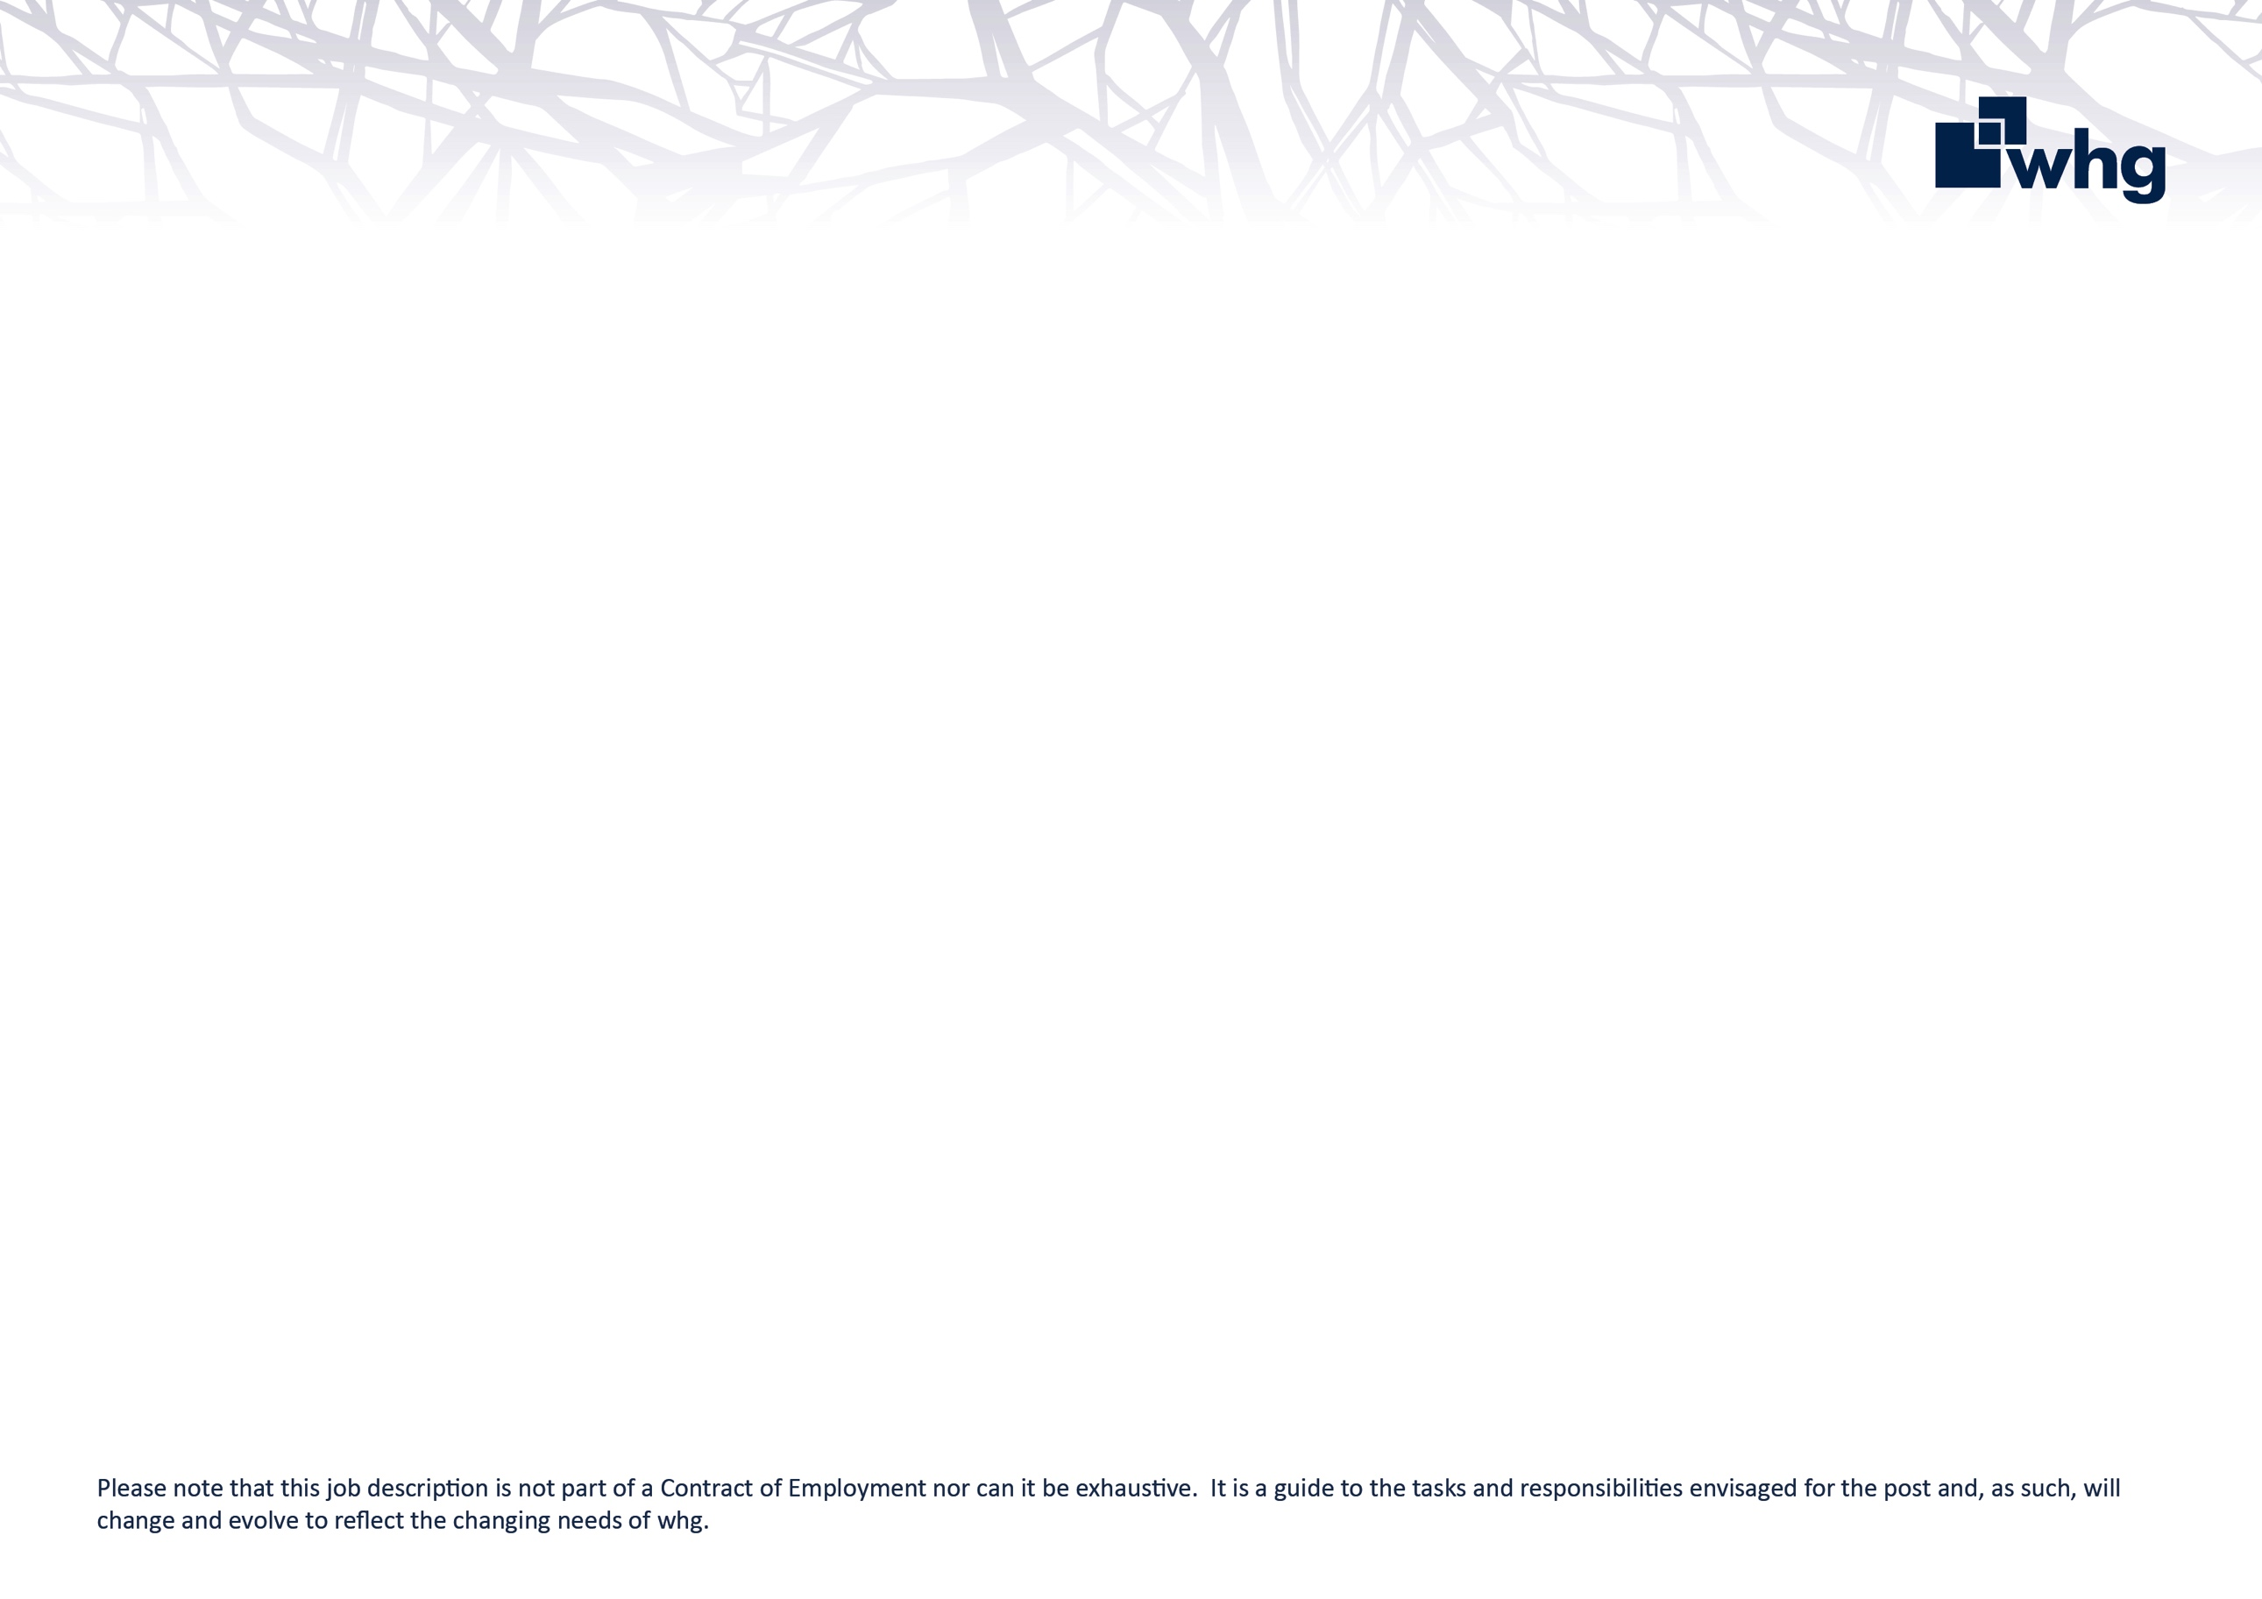You will play a vital role in establishing and embedding a centralised PMO function to support the successful delivery of the Business Change portfolio and the wider six transformation programmes of whg’s Our 2030 Plan. You will provide strategic oversight, coordination, and assurance across key transformational programmes, enabling governance, visibility, and delivery confidence across the organisation.

**What are my key responsibilities?**

Support in defining, and maintaining, a central PMO service that enables structured oversight of all transformation activity.

Work closely with Programme Leads, Lead Project Manager, Lead Business Analyst, Change & Adoption Lead, and key stakeholders across the business to embed PMO disciplines.

Support the development of change delivery frameworks, tools, and templates.

Coordinate governance cycles and reporting for key governance panels and boards. Includes developing and delivering consistent, timely, and insightful reporting that informs decision-making at senior and executive levels.

Provide constructive challenge and assurance across transformation programmes and projects to ensure plans, documentation, and outcomes are managed efficiently, and effectively. Includes establishing baselines to measure progress against.

Supporting Programme Leads with maintaining oversight of all initiatives being delivered across the six transformation programmes

Oversee a central RAID log, ensuring risks, issues and dependencies are captured, monitored, and escalated as needed.

Support the benefits tracking processes for transformation activity from identification, through to delivery and post-implementation review.

Support the culture of continuous improvement through assurance reviews, and administering the lessons learned process.

Maintain a library of PMO templates, artefacts, and best practice materials.

Responsible for centrally managing and collating portfolio resource requirements, working with stakeholders to highlight and resolve risks and issues.

Support prioritisation discussions and ensure clarity of who is working on what across the portfolio.

Support the implementation, usage and administration of a Project Portfolio Management (PPM) tool to manage and monitor projects.

**Relationships**

Reporting to the Head of Transformation, you will work closely with Project Managers, Business Analysts, Change & Adoption Lead, Programme Leads and key stakeholders across the business, acting as the expert portfolio support, report and assurance.

**Role Requirements:**

There are certain qualifications, experience and attributes we are looking for to operate effectively as PMO Lead:

* A recognised project or portfolio management qualification (e.g. PRINCE2, MSP, APM PMQ, P3O).
* Strong understanding of portfolio, programme, and project governance principles.
* Knowledge of risk management, benefits realisation, dependency management and delivery assurance.
* Familiarity with transformation delivery within a regulated or public sector environment is desirable.
* Proven experience in a PMO or portfolio oversight role, ideally within a complex, multi-programme environment.
* Experience designing and implementing governance frameworks and reporting structures.
* Skilled in stakeholder engagement and cross-functional collaboration with demonstrable success in influencing senior stakeholders through evidence-based portfolio data.
* Experience managing or overseeing the implementation of reporting and resource planning processes.
* Highly organised, methodical, and delivery focused.
* Strong analytical and data interpretation skills with an ability to translate findings into recommendations.
* Able to work independently while coordinating input from multiple teams.
* Passionate about enabling change and helping teams succeed.

**whg’s values and behaviours**

At whg we have an ambitious aim to be an exceptional place to work that attracts, develop and retains talent. We recognise that our success as a business depends largely on the quality and commitment of our colleagues; our values set out in our 2030 plan identify the behaviours that we expect all colleagues to display at whg.

|  |  |
| --- | --- |
|  | Trustworthy  You can rely on us. We are honest in everything we do. |
|  | Accountable  Taking responsibility for our actions and owning the delivery of our promises. |
|  | Excellent  Striving to be the best and delivering the best outcomes for customers and the organisation. |
|  | Respectful  Valuing people and treating everyone with empathy and fairness. |
|  | Collaborative  Achieving great things by working together. |