Senior Solutions Architect

**Senior Solutions Architect**

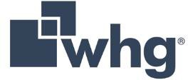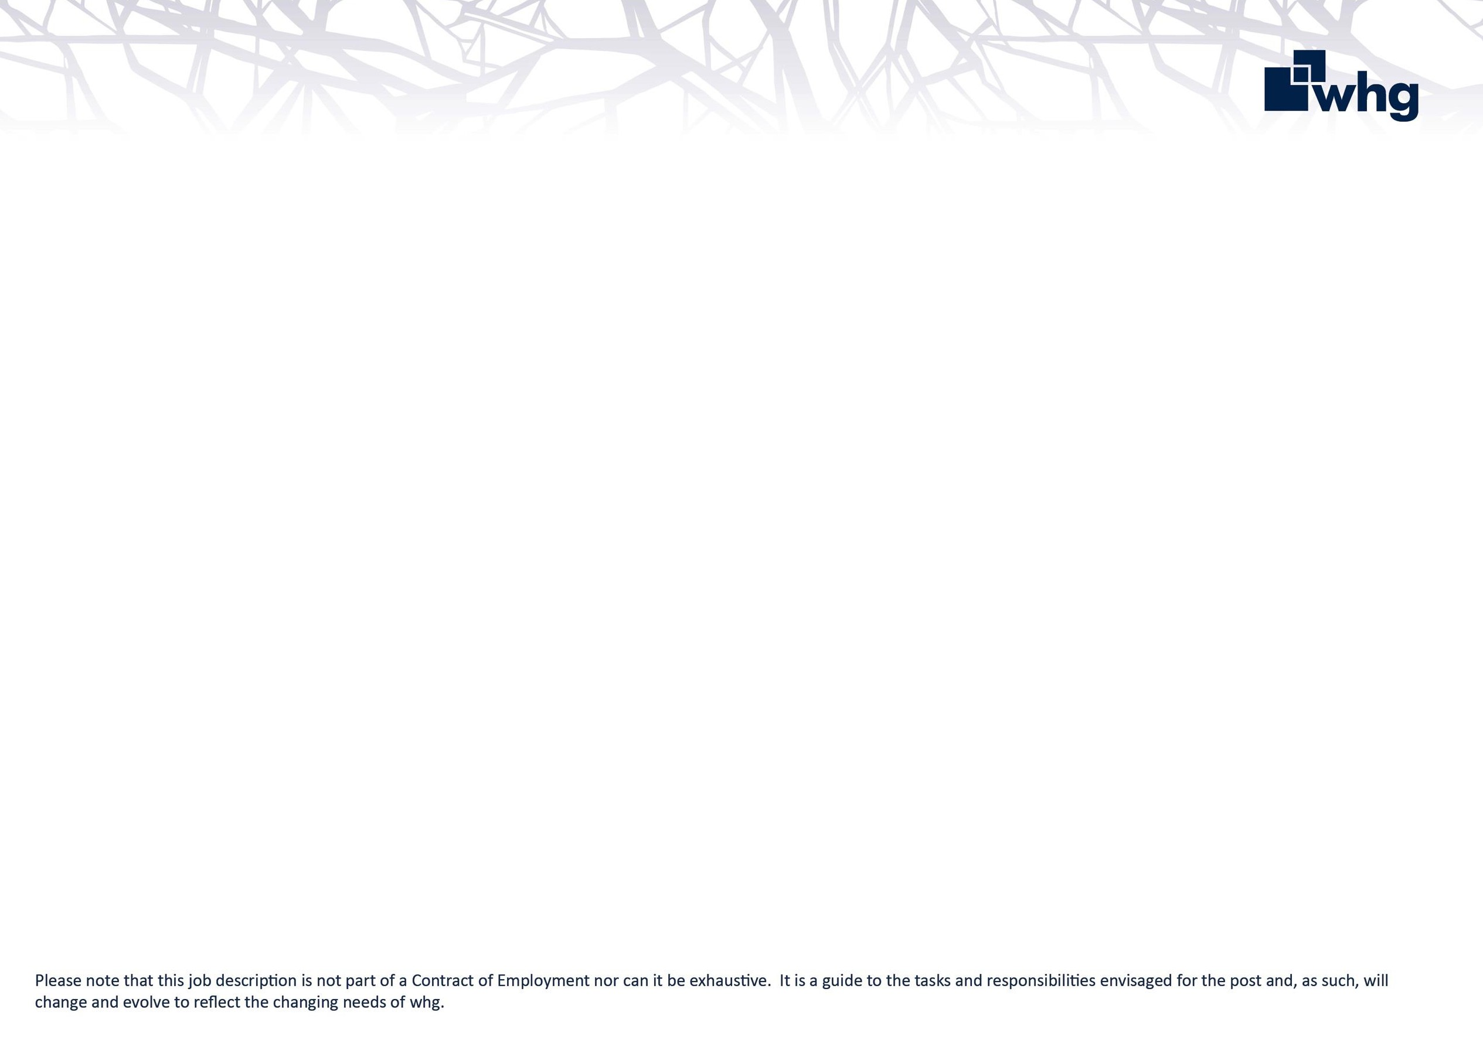

As a Senior Solutions Architect, you will be a highly experienced and accomplished architect recognised for the ability take on our biggest and most complex architecture and design challenges.

You will possess deep technical expertise, a strategic mindset and a proven track record of designing and implementing robust IT solutions at scale that meet the continuing needs of the business operational and transformation activities.

You will be highly skilled in Infrastructure & Security Architecture principles and have an excellent understanding of Enterprise Architecture.

You will be part of a small but talented team of Infrastructure Specialists and Solutions Architects. You will be a strong leader who can collaborate across departments, mentor junior staff, and drive architecture principles and strategy across the organisation.

# Key responsibilities

Working closely with the Infrastructure Manager, Solutions Architect and Security Manager, you will be responsible for the complex solution design and development of systems and services of various sizes, including how they interact with their surroundings, and how they evolve over time. You will also

work closely with other IT teams and Business stakeholders on multiple projects or problems to ensure broader architectural thinking is always considered.

As the Senior Solutions Architect, you will have the autonomy to keep ahead of technology and innovation. This includes IT Infrastructure, Cloud, Security, Data, AI, End User Compute, iOT, SAAS / PAAS and Applications relevant to housing. You will be expected to Incorporate relevant solutions trends and direction into a strategic view and communicate this information to the Technical Design Authority as an appropriate strategy or roadmap.

Deputy chair of the Technical Design Authority.

Helping to build a diverse, inclusive culture across the technical architecture function, growing awareness, inclusivity and balance.

Able to motivate others to adopt and sustain resultant changes in organisation, roles, processes, systems and information.

Define, create, document and manage a full

set of solutions working collaboratively with others and across multiple projects and programmes.

# Relationships

Post holder will report directly to the Infrastructure Manager.

You will need to develop and maintain effective working relationships with all areas of the business including senior stakeholders. You will also be required to forge excellent relationships with external partners and stakeholders.

# Role Requirements

This is an exciting time for whg, and as a Senior Solutions Architect, we are looking for extensive hands-on experience attained by working across a multitude of Public and Private Sector environments. This should be backed up by a demonstrated track record of applying best practice Architecture principles to support significant IT Transformation programmes.

# *Previous experience of IT Transformation within the housing sector would be hugely beneficial.

* Hold valid certificates or have extensive Design and Operational experience of Microsoft Azure, M365 & AWS Cloud Services.
* 7+ years’ experience in a Solutions Architecture role
* Subject Matter expert (SME) in Next Generation Firewalls (NGFW) & Secure Access Service Edge (SASE) Technologies.
* Highly proficient in Enterprise Network design including LAN, WLAN, MPLS/SD-WAN technologies.
* SME in Zero Trust Network Architecture (ZTNA) principles.
* Highly proficient in Security tooling and a good understanding of security frameworks such as ISO 27001 and NIST 800-53.
* SME in Least Privilege principles and Role Based Access Control (RBAC) Design & Implementation.
* SME in Microsoft Core Services including Active Directory, PKI, DNS, DHCP, Identity (Microsoft Entra).
* SME of Microsoft Server and M365 stack.
* Strong working experience of designing, deploying/migrating Microsoft SharePoint, OneDrive for Business and Microsoft Teams.
* Demonstrated extensive knowledge of Business Continuity processes and procedures as well as Disaster Recovery solutions.
* Extensive Mobile Device Management (MDM) platforms experience coupled with Client Operating systems.
* SME in L1 & L2 Hypervisor technologies such as VMWare, Hyper-V, HCI platforms such as VX-Rail, HPE Synergy, Nutanix & Cisco UCS.
* Experience leading technical teams and delivering user- centred services in an agile environment.
  + The ability to build consensus between diverse and often conflicting interests, working with technical and non- technical stakeholders to achieve agreement on technical plans.
  + The ability to look beyond immediate technical problems and identify the wider implications.
  + Challenging entrenched practices, looking for deeper underlying problems to solve, and larger opportunities for digital transformation.
  + Communicating the vision for whg IT services to key business stakeholders working in multi-disciplinary teams that bring policy and delivery together.
  + Playing an active role in the Architecture community within the housing sector. Sharing interest and events, your knowledge of best architecture practice, tools and techniques.
  + You will be able to operate effectively when the situations encountered are dynamic, evolving, or novel in complexity.

# whg’s values and behaviours

At whg we have an ambitious aim to be an exceptional place to work that attracts, develops and retains talent. We recognise that our success as a business depends largely on the quality and commitment of our colleagues; our values set out in the 2030 Plan identify the behaviours that we expect all colleagues to display at whg.

|  |  |
| --- | --- |
|  | You can rely on us. We are honest in everything we do. |
|  | Taking responsibility for our actions and owning the delivery of our promises. |
|  | Striving to be the best and delivering the best outcomes for customers and the organisation. |
|  | Valuing people and treating everyone with empathy and fairness. |
|  | Achieving great things by working together. |