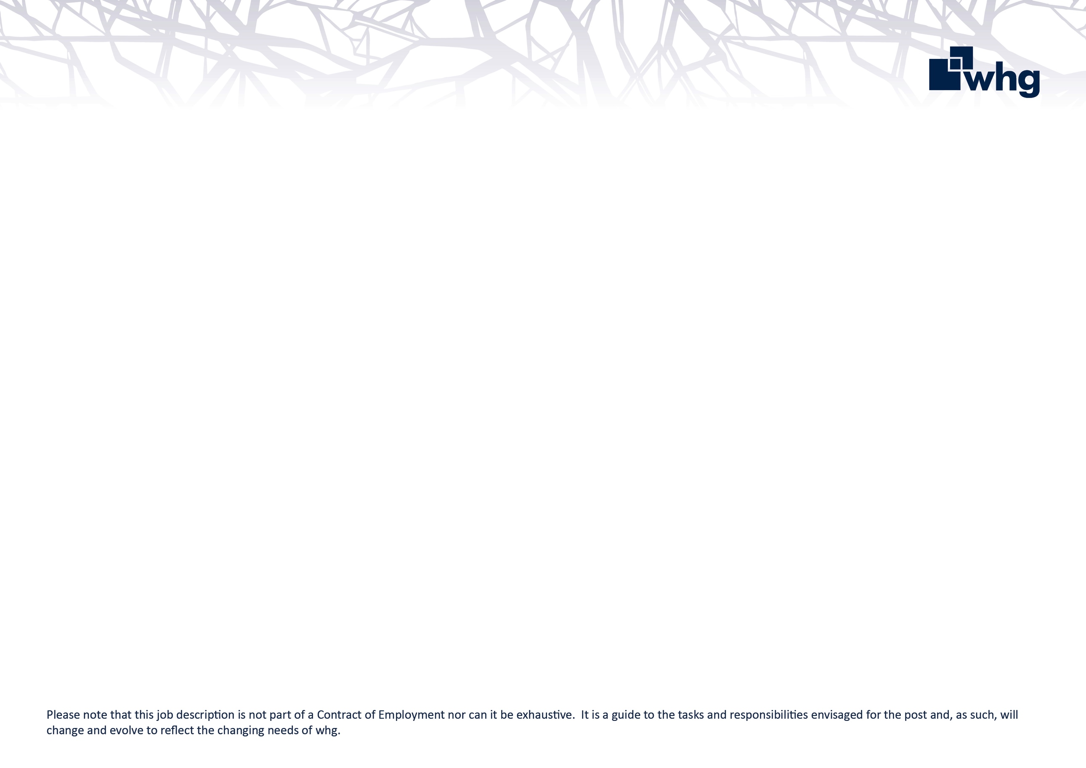

Your role is to provide administrative support to the Stores and Transport Management Teams, and support in providing an efficient and customer focused front of house service.

**Administrator Stores & Transport**

**What are my key responsibilities?**

* Deal with colleague, supplier and third-party queries in a polite and efficient manner.
* Carry out general administration duties for the Managed Stores Service, Managed Waste Service and Managed Transport Service.
* Photocopying, scanning, computer filing and disposal of documents.
* Updating Microsoft Excel tracking spreadsheets, or databases.
* Record and analyse results of audits, identifying any discrepancies to Stores/Transport Management Team.
* Updating supplier systems, Waste data portal, or Transport data portals.
* Administration for distribution of Vehicle key sets, business fuel cards, driver offences and fines.
* Process Vehicle defect or damage claim forms, including relevant pictures and recording these onto whg and supplier systems.
* Administration of Purchase Orders and checking invoices for discrepancies.
* Attending meetings, updating action notes, or, noting new actions on Microsoft Excel tracking spreadsheets where required.
* Undertake any other duties commensurate with this post when requested.

**Relationships**

You will report directly to the Transport Operations Manager.

Within the Company you will work closely with Stores and Transport colleagues, Trades colleagues and Planners.

Outside the Company you will work with suppliers and third parties.

**Role Requirements**

* General administration and customer service experience.
* The ability to build trust and co-operative working relationships.
* Self-motivated and accountable for the delivery of work output.
* Experience of providing excellent administration support to several people within a team environment.
* Confident with a positive approach and the ability to remain calm when dealing with difficult situations in a respectful, effective, professional manner.
* A strong communicator with the ability to work collaboratively across teams and independently.
* Strong organisational skills and attention to detail.
* The ability to work under pressure and to deadlines in a fast-paced environment.
* The ability to anticipate and identify problems and determine the appropriate action to resolve them.
* Good IT skills which include the ability to confidently use Microsoft Office applications, including Outlook, Excel, Word and company databases to accurately and efficiently record or send data and documents.

**whg’s values and behaviours**

At whg we have an ambitious aim to be an exceptional place to work that attracts, develops and retains talent.

We recognise that our success as a business depends largely on the quality and commitment of our colleagues; our values set out in the Corporate Plan identify the behaviours that we expect all colleagues to display at whg.

|  |  |
| --- | --- |
|  | Trustworthy  You can rely on us. We are honest in everything we do. |
|  | Accountable  Taking responsibility for our actions and owning the delivery of our promises. |
|  | Excellent  Striving to be the best and delivering the best outcomes for customers and the organisation. |
|  | Respectful  Valuing people and treating everyone with empathy and fairness. |
|  | Collaborative  Achieving great things by working together. |